WORKFORCE HEALTH PROJECT

‘Making people healthier and happier within their working environment’

Author Gulay Nil Ermiya
Co Author Erim Metto JP, Buse Konuksever, and Dr Mek Mehmet Yesil
Report ownership Turkish Cypriot Community Association
Table of contents

Title Page Number
  - 1.Abstract 2
  - 2.Forward 3
  - 3.Acknowledgements 4
  - 4.Project Aim 4
  - 5.Project Outline 5
  - 6.Delivery Team 6
  - 7.Introduction/ Background 7
  - 8.Methodology 8
  - 9.Findings 9
  - 10.Conclusion 19

- Abstract
This report will review the researched evidence on health and wellbeing of Turkish Speaking employees who are employed in micro-businesses within the remits of the London Borough of Hackney. In addition, the report will further evaluate the impact of intervention in the form of advice, provided to participants within the research and how that advice has affected their wellbeing. Further to this, the report will focus on statistical data gathered which will be thoroughly analysed in order to enhance our understanding of the health and wellbeing of individuals whom work for micro-businesses.
The report will also discuss any future changes which may be required in order to improve any further studies, focusing on the quality of information, how information can be shared and consider whether the Project could be carried out amongst other Black and Ethnic Minority (BAME) communities.
The report will also touch on some of the challenges that were faced during the Covid-19 pandemic and how this impacted the Project overall, which occurred during the last stages of the research and intervention.

- Forward
It is commonly accepted that within the primary health sector, BAME communities who work within micro-businesses’ health and wellbeing are adversely impacted in comparison to other members of the community.
It has been demonstrated that BAME communities have higher levels of hospital attendances for illnesses that root from their workplace. For example, there are higher incidences of cardiovascular disorders and diabetes, which is found to have a link with lower power pay, limited access to certain health services, and high levels of stress at work. In many BAME communities, it can be argued that access to information in relation to health and well-being is significantly less than other members of the community, and in particular those who have barriers to accessibility due to either language, culture, gender, religion or other beliefs. Access to information on wellbeing and knowledge of health-related issues is also lacking in many BAME communities, in particular those who have barriers to accessibility due to language, culture, gender or religion.
Turkish is the second most spoken language within the London Boroughs Enfield, Haringey, Hackney and Islington. Our evidence of need within the Turkish Speaking communities is based on collaborative partners’ combined knowledge that extends to over 100 years of provision. Our major pre-research findings indicate that within the Turkish Speaking communities, there are extremely high levels of; smoking, heart related illnesses, lack of physical activities and extremely high levels of mental health issues. These are only being partially met within existing provisions as services are based on beneficiaries deciding to use services rather than the services outreaching to engage.
The Turkish Cypriot Community Association (TCCA) is the largest of Turkish Speaking Charities in the UK in terms of turnover and staffing. It operates in Boroughs with a high concentration of Turkish Speaking individuals. It provides services related to health, care, well-being, education and support and all services are needs based. In December 2018, TCCA tendered for a project under the Hackney Healthy Activities Grant 2019/20. The project funding was aimed at providing support to Turkish Speaking employees who work in the London Borough of Hackney for micro businesses, the aim being to reduce the amount of time away from work due to ill health. The aim of the Project was also to research reasons for high levels of work based illnesses and through an evaluation suggest ideas that would improve health and wellbeing within the Turkish speaking community within the Borough of Hackney through providing seminars as well as information packs for participants of the Project.
As an addition, TCCA embarked on delivery of this project through a partnership. This brought together skills of various Turkish Speaking organisations that have skill sets relative to sub sections of the Turkish Speaking communities i.e. Hackney Cypriot Centre catering for Turkish Cypriots. The other partners include Derman, Pekunluler and Halkevi.
- Acknowledgments

We would like to thank our partners in this project; Pekunluler, Day-Mer, Derman, and Hackney Cypriot Centre. As well as all the Hackney Council Representatives.

Mr Rustem OZDEMIR London Alevi Cultural Centre and Cemevi
Ms Cemile Goksun Hackney Cypriot Centre
Mr Cetin Ozdemir Pekunluler Dernegi
Ms Nursal Tas Derman
Mr Guluzar Yaldiz Halkevi
Mr Orhan Dil DAY-MER
Mr Yashar Ismailoglu TCCA

Finally, we would like to thank all the employees and their workplaces who took time away from their busy days to take part in our research, we hope this project has been useful for you and has contributed to your health in a positive way.

- Project Aim:
The aim of this project supporting Turkish speaking employees who work for micro-businesses to reduce the amount of time away from work due to ill-health.
Additionally, the project aims to improve the physical and mental health of employees through providing services such as access to bi-lingual culturally sensitive information, deliver seminars regarding how the employees can improve their health and well-being as well as providing participants of the project with information packs to assist them further.
Furthermore, the project aims to introduce schemes that can support and significantly impact employees at work i.e. cycling to work schemes, promotion of hydration at work, smoke cessation. Change the mentality with the introduction of this project empowering employees to better health; both physically and mentally.

- Project Outline

Information was gathered from 63 Turkish Speaking micro-businesses in Hackney (the actual aim was 52, however we have over-reached to more businesses) –including 223 participants regarding their physical and mental well-being. The businesses were revised later as part of monitoring process to help support them to improve their health. In the final quarter of the project the seminar was due to take place.

However, near the end of the Project, the Covid-19 Pandemic occurred and as a result the Project focused on creating an online platform whereby employees/participants of the Project will have direct access to all the services available. As an alternative to face-to-face seminars and surgeries, YouTube videos have been uploaded.

With the help of media outlets, the Project has reached hundreds more of the Turkish speaking community in Hackney, than originally planned.

This project has been highly beneficial to the Turkish speaking employees within the Borough of Hackney, and rather than these employees feeling like their health and wellbeing has been overlooked the employees now feel more empowered and more noticed within the community. It can be stated that there are no delivery segments which replicate this service, directly outreaching to the employees within micro-businesses.

- Delivery Team

The individuals below have participated throughout the entirety of the Project in accordance with their abilities and specialities.

TCCA Management Team
Erim Metto Chief Executive Officer
Niyazi Enver TCCA Chair
Yashar Ismailoglu Associate Support
Mirza Shipkoyle Accounts
Sultan Ozkurtlar Intern Management
Patrick Gorman FIE Placement Director

Project Delivery Team
Ahmet Havali Project Manager
Buse Konuksever Project Officer
Gulay Nil Ermiya Project Officer/Admin- Occupational Psychologist
Thomas Taylor Communications Intern
Grant Spagat Research Intern
Dr Mek Mehmet Yesil Cancer Ambassador
Dr. Akan Efe Cardiologist
Ozgun AVINCSAL Genetic Bioengineer
Dr. Teoman Sirri Diabetes Specialist
Ebru Kurtarankartal Workforce Health Specialist/ Sessional Worker

Media Partners
Euro Genc TV- Alp Ermiya
Avrupa Gazete- Vatan Oz
Olay Gazete- Faruk Eskioglu
Euroziyon- Mustafa Koker
Haber Gazete- Ozcan Yoruk

- Introduction/ Background
Purpose of Engagement of Research
Absenteeism is a great issue in today’s world of work, although it has decreased in the last 4 years in both the public and private sector, figures have only changed slightly, (CIPD, 2016). Reports show that 60% of 1,000 surveyed employees have had an unplanned absence in 2014 and 57% admitted to calling sick despite not really being sick (Timeware, 2015). Absence has become an important development which needs to be cracked in order to improve the effectiveness of businesses, as well as the mental and physical well-being of employees.
Turkish Speaking Community in Hackney
According to the Hackney Council website statistics, Turkish speaking residents account for about 6% of Hackneys population. Turkish Cypriots first arrived in the area in the 1930s as commonwealth citizens. Later in the 1970s, 1980s and 1990s due to economic and political reasons many Turkish and Kurdish citizens flee to London.
The Turkish community are a major part of the Hackney Council and contribute to the economy with their businesses in the area and therefore are a crucial and key group of people to based work-related research around. To keep the productivity high of these groups, we must understand their physical and mental well-being trends and look for ways to improve them.

- Methodology
This research is based on qualitative and quantitative evaluation methodologies. Three sets of questionnaires used over time for monitoring the participants. Participant tick responses (quantitative) on questionnaires but there is an optional part of the questionnaire where participants can leave further comments, (qualitative) as well as having informal conversations with data collectors/researchers. These questions seek for information into the demographics of the participants, their personal information, their health based figures, and entails emotion based questions other related health questions.
Questionnaire 1- this is the starting point of the research where the researchers get to understand each employee. Such as their background, how much water they consume, whether they are a smoker or drinker, their eating habits and calorie intake, how they rate their physical and mental health and how much they know about it, as well as understanding how much they know about the support that is available to them.
Following this questionnaire, verbal feedback is given to the participant as well as a participant information booklet which will help advise them on their physical and mental well-being.
Questionnaire 2 - This is a follow up questionnaire following the first one, which also asks the same questions, but looks for improvements in health and behaviour. Researchers continue to provide support and advice, carrying them forward to the next stage of the research.
Questionnaire 3 - This is the final questionnaire which looks to monitor the participant for a final time. It also seeks for feedback from the participants to see how useful they thought the research was, so this can be used for future reference for any further research.

- Findings
Participants by Gender
Overall, 223 participants took part in this research.
159 Males (68.8%) and 64 females (27.7%).
(From 63 Turkish Speaking micro-businesses in Hackney)

Figure 1: Participants by gender statistics
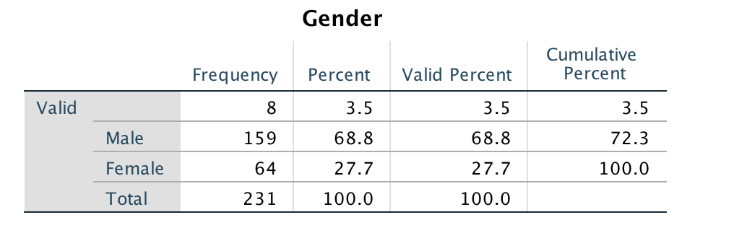
Weight:
The finding shows that the participants weight range from 48kg- 185kg.
Findings show that those with higher weight (90+kg) were more likely to give lower ratings of physical and mental well-being reporting with responses of “poor” or “Satisfactory”.

Diet:
Water consumption – those who drank more than 1 litres per day were more likely to give higher reports on physical and mental well-being than those participants who drank less than 1 litre per day.

Daily meals – Those participants who reported an inconsistency of not eating 3 meals per day, as well as skipping breakfast were more likely to show lower signs of mental and physical well-being. Additionally, those who were likely to eat a high quantity of take-away’s and from restaurants per week, were also more likely to show lower signs of mental and physical well-being.

Calorie consumption- Those who reported above average calorie intake were more likely to give lower ratings of physical and mental well-being. However, there is also a lack of understanding of calorie intake in the Turkish speaking community. Lots of verbal feedback was given to those researchers collecting data. It was reported that most participants did not understand how to measure calorie intake when eating and what the maximum calorie in- take should be.

Smoking:

Figure 2: First Visit Smoking Statistics
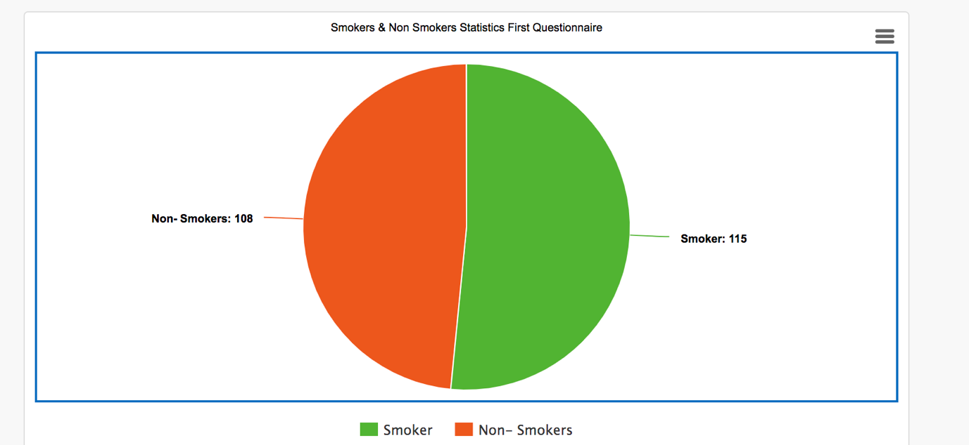

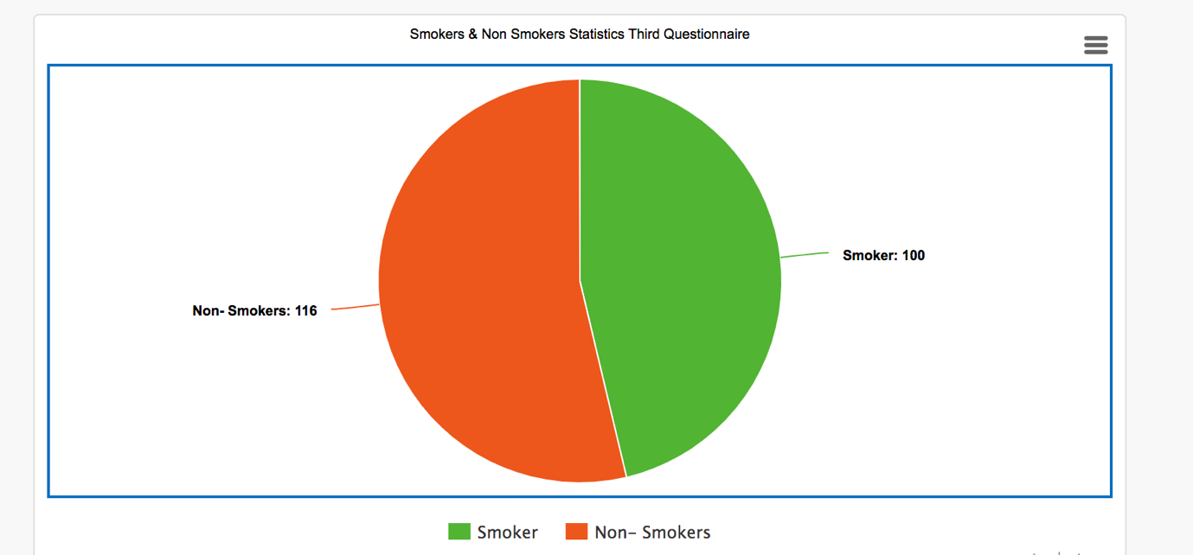
Figure 3: Second Visit Smoking Statistics

At the start of the research with the data collected from the first questionnaire, 51.6% of the participants were smokers and 48.4% are non-smokers. When research was collected again for the second questionnaire it was found that there were a decrease of smokers to 49.1% and an increase to 50.9 % for non- smokers. Based on some verbal feedback given on the 3rd visit to participants, it was reported that the research motivated them to stop smoking.

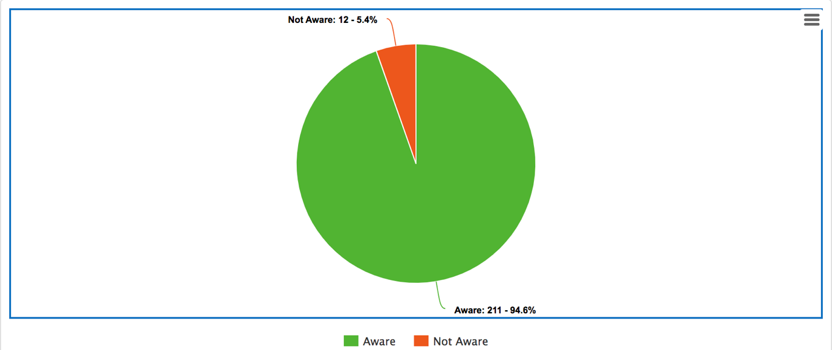
Figure 4 : Awareness of effects of smoking on health

The research shows that 94.6% are Verbal are knowledgeable about the effects of the smoking, however verbal feedback given by the researchers found that some participants were unable to give up smoking due to the stresses of work.

Employees were monitored during these processes and at the end of the project were given the employee information pack which give information how to stop smoking, entailing ways to stop smoking even when stressed. Furthermore, the online seminars on YouTube gives details to employees on how to reduce smoking and explains more in detail its effect on health.

Alcohol Consumption

Figure: Alcohol consumption amounts

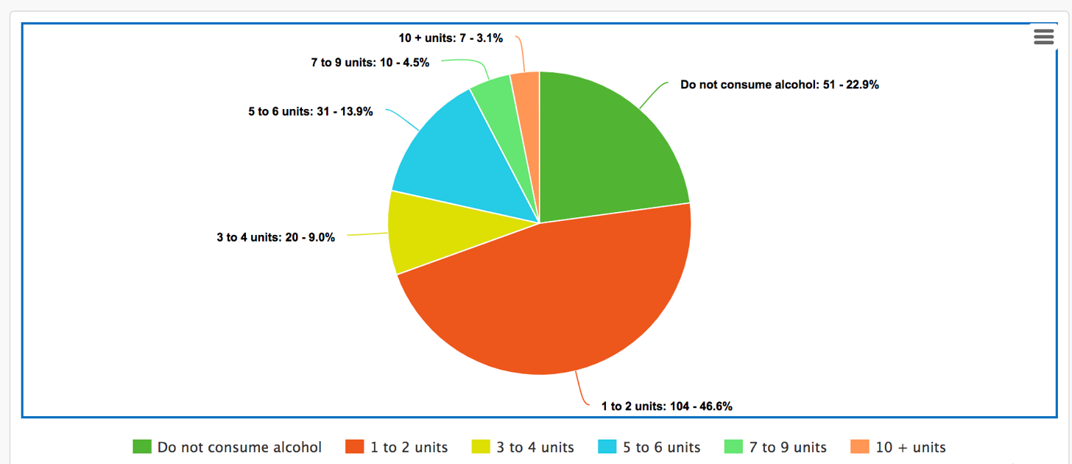
Figure 5 : Alcohol consumption of participants

44.6% of the employees from the Turkish speaking community in Hackney drink between 1 to 2 units of alcohol a week, which is a low amount and 22.9% of the participants stated that the did not consume any alcohol. However, 3.1% of the participants do consume high amounts of alcohol, 10+ units per week. Therefore, although the percentage is low, those participants who did consume high levels of alcohol were monitored and given advice during the duration of the project. Information regarding reducing alcohol levels are provided at the end of project employee information packs, as well as the online YouTube seminar by our project health expert.

Figure: Whether participants are aware or not of the effects of alcohol on their health
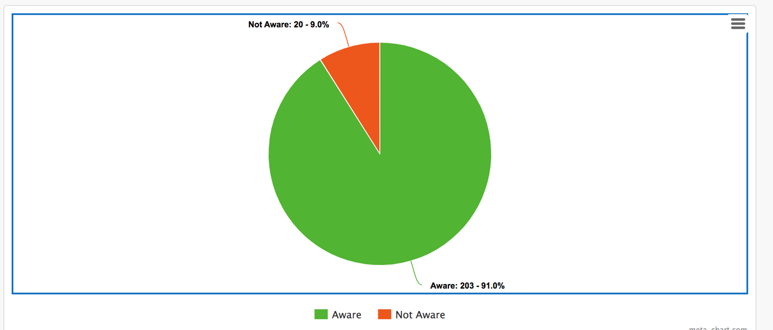
Figure 6: Are participants aware of the effects of alcohol on their health?

91% of the participants stated they are aware of the effect’s alcohol have on their health; however, a majority of the participants still drink alcohol. Therefore, it is suggested that even though they are aware, they have not made any attempts to make changes to their lifestyle. It is recommended that future research should be carried out to why individuals continue to adopt unhealthy lifestyle behaviours, regardless of their knowledge of the affects it has on their health. This will enable a better understanding of the motives behind it and find ways which will help motivate employees to change their behaviours.

Physical Activity
Figure 7: Forms of travel used by employees
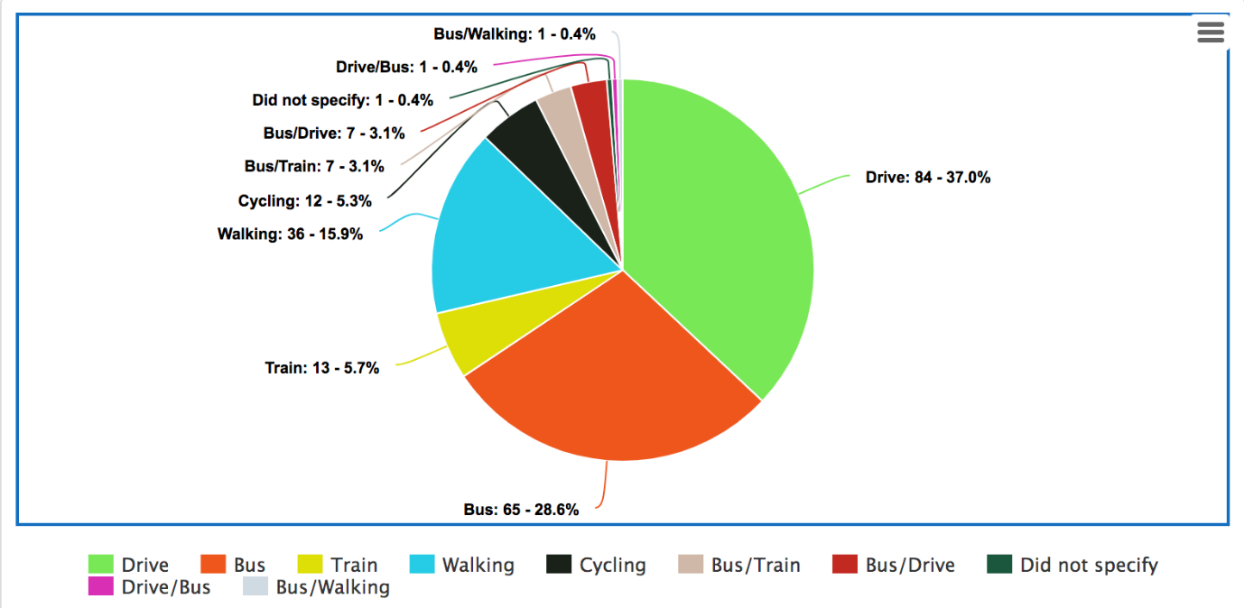

Most of the Turkish speaking community in this research drive to work accounting for 37%. Walking and cycling methods of travelling to work is the least frequent with walking being 15.9% and cycling being 5.3%. Based on these findings, participants have been advised the benefits of walking to work as a form of exercise and part of a healthy lifestyle. As well as the benefits of cycling to work. Employers have been informed that they are eligible to apply for this as a tax-free benefit, and employees will receive discounts on equipment’s.

Figure 8: The strengthening activity per week of the employees
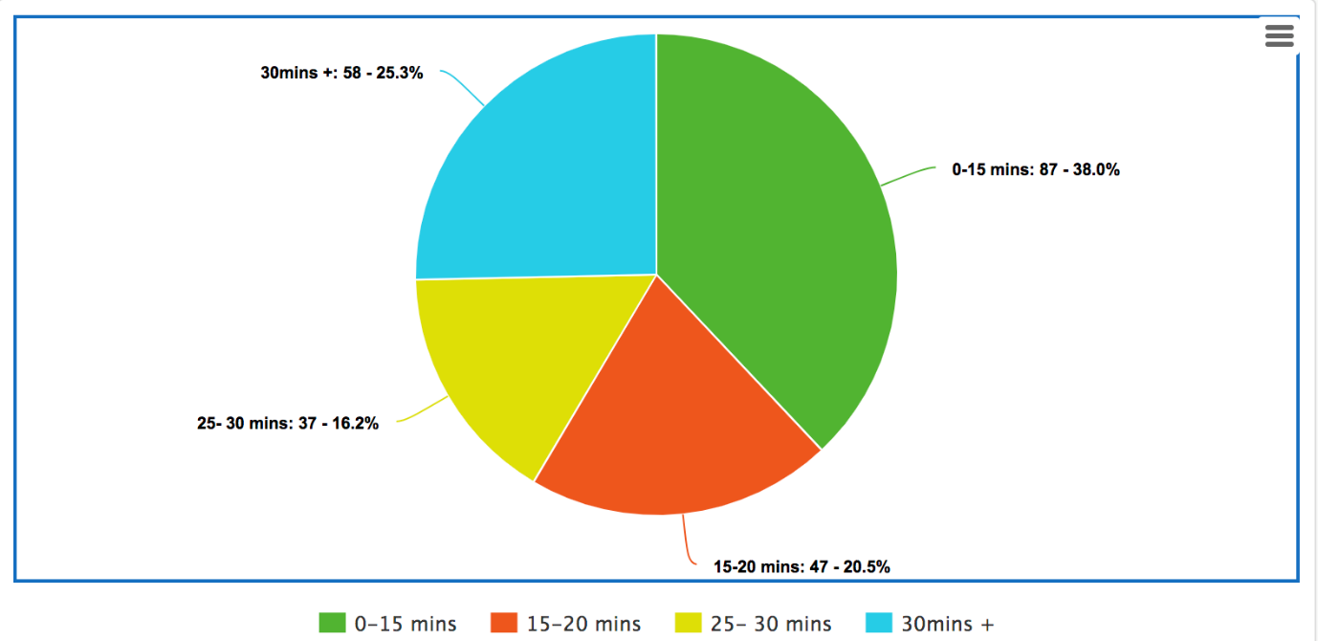

38% of the employees from the Turkish speaking community in Hackney only do between 0-15mins of strengthening activity per week, however 25.3% also stated they do 30mins+ so some employees are seen to be highly active. However, those who reported less amount of physical activity per week, also reported lower reports on physical and mental health. Therefore, participants were informed that increasing their activity levels per week would increase their physical and mental well-being. Participants were given verbal feedback, as well as receiving an information pack on the first visit. At the final quarter of the project, the participants also have access to an employee information pack prepared by the medical experts based on the outcomes of the research. They also have access to the YouTube links which give them advice on sports and exercise by the project sports health expert.

Are they “happy” with their workplace? What does this mean for the research?
Figure 9: Are participants happy or not happy with their workplace
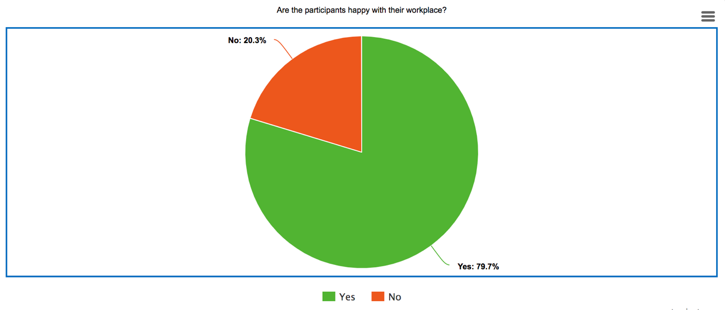

The research has found that 79.7% Turkish speaking community working in the area of Hackney who participated in this research are happy with their workplace. Whereas 20.3% of the participants in the research are happy. A closer analysis of these specific participants, found that those who were unhappy with their workplace, also showed lower levels of physical and mental well-being, and are less knowledgeable about physical and well-being.
Therefore, this research has highlighted that there is a link between these factors. It could be suggested that either changing the work environment could help positively impact the physical and mental well-being of employees. In reverse it is suggested that making the employees more aware of ways they could individually boost their physical and mental well-being could make them happier in their workplace and more energised for work.
Knowledge and awareness about physical and mental well-being:

The research suggests that great majority of the participants in this research have never had a mental health examination or have not had one in the last 6 years. This shows the lack of importance placed on mental health by the Turkish speaking community, even though there are low reports of mental health. Moreover, participants are willing to learn and have made verbal and written comments that they wish to know more about mental health & how to identify their triggers.

Participants have also made comments that they were not aware that online there were certain NHS tests available to the public, and they were only made aware after taking part in the research. One participant in particular commented and said that “ it doesn’t matter how healthy you are, sometimes you can be unlucky enough to get cancer.

Language is a barrier
One factor which was highlighted in this research was that some participants verbally stated that the reasons why they had limited knowledge about the services available to them and also the lack of knowledge of physical and mental well-being is due to the barrier of language. Most things available to the public is in English and some those who migrated to the UK in the last 5 years struggled with English. Some participants commented that they were happy that this information was presented to them in Turkish.

This therefore highlights that research like these which hands out Turkish as well as English sources to the participants, is highly useful to help educate them on physical and mental well-being. It is recommended that this research to be carried out in different areas where the Turkish speaking community reside and work in. This will be beneficial as it will not only help boost the individual health of the people in the research, but in effect increase the productivity of workplaces and as a result boost the economy.
Discussions:
- Improvements – with the seminars and write up packs
- Lack to change – some hard to change-
- Language barriers
- Information packs for employees
Difficulties faced in the research

It has become evident from our research that some participants did not want to fill out the second or third questionnaire. This was due to lack of time and to the lack of understanding of the importance of the research. This issue was overcome by explaining our research in detail and returning to the workplaces when it was a suitable time for the employees. This required constant contact and was some-what time-consuming.

There was an issue of finding the same participant at the same location again, this is due to employees work shifts and many other contributing factors. This required hard work to track everyone down, in order them to fill out the next set of questionnaires. Therefore, it was a very time-consuming process. Additionally, during the period of the research, one company shut down and changes names, therefore researchers were not able to contact the employees who previously worked there and were removed from the research. Their data was still used as part of the analysis for the first half of the research.

There was a change of admin officer during the project; the transition period caused some delay in work. However, this was very minimal as the new admin officer was already on the project as a sessional worker. This, therefore, meant she knew the nature of the project and is an experienced in her field, so the project continued without any issues.
Furthermore, the outbreak of the coronavirus pandemic meant that some last visits were not able to take place. As a result ,the rest of the mentoring was done over the phone. Additionally, the health seminar that was due to take place at the end of the project was cancelled and as a replacement online YouTube seminar videos have been uploaded which the employees as well as the rest of the public can access and make use of the useful health information.

Media support during the project:
During the project, it was aimed to raise awareness of the project amongst individuals that are not directly involved/participating within the Project. This was done by publishing a monthly article in community newspapers, such Avrupa Gazete and having a short slot on community channel Euro Genc TV, advising individuals on health and wellbeing related issues, and ensuring that the Project has an ongoing social media presence.
Furthermore, to reach out to individuals unaware of the Workforce Health Project within the Hackney Borough, we created a Facebook group called “Workforce Health Project”. The project’s Facebook group has been running successfully. Regular posts about physical and mental well-being are posted by our project members. The posts contain valuable information available to the community advising them on issues. Additionally, motivational quotes have also been shared to help inspire the Turkish speaking community.

Conclusion

In conclusion, because of the themes highlighted in the research; the following seminar topics were picked; General health. Sports/Exercise, Stress Management, Alcohol Consumption, Smoking, Female Health, Male Health and Well-being in the workplace.

From this research, it is recommended to introduce schemes that can support and significantly impact employees at work i.e. cycling to work schemes, promotion of hydration at work, smoke cessation. Additionally, it important to change the mentality and mind set of employees. With the introduction of this project, has led to empowering employees to better health; both physically and mentally. Therefore, further research should be conducted in different boroughs in London to get a better understanding of employees.
Furthermore, after the outbreak of the coronavirus pandemic, it was highlighted from some the participants that different patterns of working are now emerging. This includes working from home and increased protection of health and safety. This gives the need for potential research to find out how employees have been affected during this pandemic and how this impacts their physical and mental well-being.

Links covering research can be found:
Website.
TCCAhealth.org

YouTube.
Tcca Tcca
TCCA1976@gmail.com

Research paper is further filed at: Academia

